KEEPER
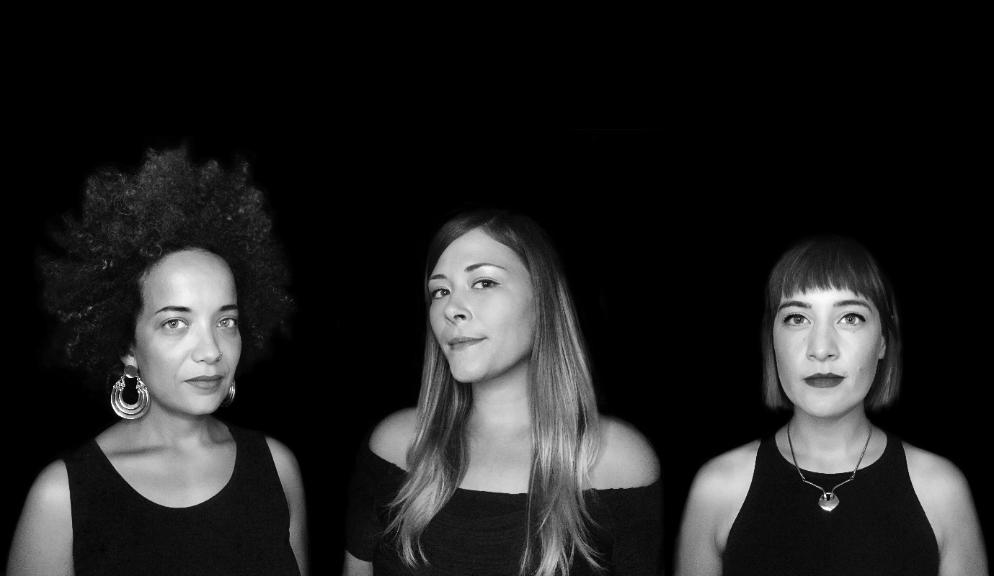
PRETTY BABY

[LISTEN]
Keeper, a trio from Austin, Texas formed by vocalists Yadira Brown, Erin Jantzen, and Kate Priestly, create an electrifyingly unique brand of style and sound they succinctly summarise as ‘synth-soul’. Together the three harmonise and weave their voices resulting in one forceful voice with an ambition of projecting and exploring vast ranges of emotion via their symbiotic musicality.
Pretty Baby is the group’s latest single. They depict it as “the story of a person who owns their voice and individuality, instead of following guidelines or structures that make one feel the need to conform”. Produced by BoomBaptist, who was also the working hands behind the trio’s first official single, the track combines slinky dub-influenced rhythms and erratic breakbeats with the fluid expressive vocals provided by the three singers. The end result is an intense, almost dark and enthralling listen with a sonic palette reminiscent of 90s UK electronic music and trip hop.
Looking to further build upon the success already established though the acclaim gained from 2016’s Corners EP and a busy festival circuit which saw the act play SXSW and Fun Fun Fun Festival, Keeper have returned with a sensational single that should get heads turning for new material that will arrive in the near future.

Pretty Baby is independently released on 13th October, and will be available on Spotify, Apple Music and other streaming platforms.

LIVE DATES
12th October – Austin City Limits After Show – Direct Support for MUNA
18th November – Synth City Festival (Austin, Texas)

